Higher Education Career Advancement & Monitoring System
A
MAJOR PROJECT-I REPORT
Submitted in partial fulfillment of the requirements for the degree of

BACHELOR OF TECHNOLOGY
in

COMPUTER SCIENCE & ENGINEERING

By

GROUP NO. 38

Aavi Agrawal 0187CS221003
Anuj Raghuwamshi 0187CS221050
Anushka Shrivastava 0187CS221053
Mahak Jat 0187CS221111
Under the guidance of Prof. Nargish Gupta (Head of Department)


Department of Computer Science & Engineering
Sagar Institute of Science &Technology (SISTec), Bhopal (M.P)
Approved by AICTE, New Delhi & Govt. of M.P.
Affiliated to Rajiv Gandhi Proudyogiki Vishwavidyalaya, Bhopal (M.P.)

November -2025

Sagar Institute of Science & Technology (SISTec), Bhopal (M.P) Department of Computer Science & Engineering
CERTIFICATE

We hereby certify that the work which is being presented in the B.Tech. Major Project-I Report entitled Higher Education Career Advancement & Monitoring System, in partial fulfillment of the requirements for the award of the degree of Bachelor of Technology, submitted to the Department of Computer Science & Engineering, Sagar Institute of Science & Technology (SISTec), Bhopal (M.P.) is an authentic record of our own work carried out during the period from Aug-2025 to Nov-2025 under the supervision of Prof. Nargish Gupta

The content presented in this project has not been submitted by me for the award of any other degree elsewhere.

Aavi Agrawal | Anuj Raghuwanshi | Anushka Shrivastava | Mahak Jat
0187CS221003 | 0187CS221050 | 0187CS221053 | 0187CS221111

This is to certify that the above statement made by the candidate is correct to the best of my knowledge.
Date:

Prof. Nargish Gupta | Prof. Nargish Gupta | Dr. Manish Billore
Project Guide | HOD, CSE | Principal

ACKNOWLEDGEMENT

We would like to express our sincere thanks to Dr. Manish Billore, Principal, SISTec and Dr. Swati Saxena, Vice Principal SISTec Gandhi Nagar, Bhopal for giving us an opportunity to undertake this project.

We also take this opportunity to express a deep sense of gratitude to Prof. Nargish Gupta, HOD, Department of Computer Science & Engineering for his kindhearted support

We extend our sincere and heartfelt thanks to our guide, Prof. Nargish Gupta, for providing us with the right guidance and advice at crucial junctures and for showing us the right way.

I am thankful to the Project Coordinator, Prof. Deepti Jain, who devoted her precious time in giving us the information about various aspects and gave support and guidance at every point of time.

I would like to thank all those people who helped me directly or indirectly to complete my project whenever I found myself in any issue,

TABLE OF CONTENT
TITLE PAGE NO.
Abstract i
List of Abbreviation ii
List of Figures iii
List of Tables iv
Chapter 1 Introduction 1
  - About Project 2
  - Project Objectives 5
Chapter 2 Software & Hardware Requirements 8
Chapter 3 Problem Description 10
Chapter 4 Literature Survey
Chapter 5 Software Requirements Specification
  - Functional Requirements
  - Non-Functional Requirements Performance
  - Security
  - Usability
Chapter 6 Software and Hardware Design
  - Use Case Diagram
  - Architecture
  - Circuit Diagram
  - Pin Diagram (For Microcontroller Only) Chapter 7 ML Module
 | 7.1 | Introduction
 | 7.2 | Problem Definition and Algorithm
 | 7.3 | ML Model Description
 | 7.4 | Result Analysis
Chapter 8 | Coding
Chapter 9 Result and Output Screens Chapter 10 Conclusion and Future work References
Project Summary
Appendix-1: Glossary of Terms

ABSTRACT

AI-Enabled Mobile Project Management System for Institutional Productivity” focuses on enhancing institutional efficiency and collaboration through an AI-powered mobile platform. It automates project planning, task allocation, progress tracking, and performance evaluation, helping users manage projects seamlessly from anywhere. By integrating intelligent recommendations, predictive analytics, and real-time updates, the system minimizes manual effort and improves decision-making. Aligned with SDG 9 – Industry, Innovation, and Infrastructure, this solution promotes innovation and sustainable digital infrastructure within institutions, ensuring improved productivity, transparency, and effective resource utilization through smart, technology-driven project management.

i

LIST OF ABBREVIATIONS

Abbreviation | Description
SDLC | Software Development Life Cycle
SQL | Structured Query Language
HTML | Hyper Text Markup Language
UML | Unified Modeling Language

ii

LIST OF FIGURES

Figure No. | Title | Page No.
Figure 1.1 : | ER diagram | 3
Figure 1.2 : | Use Case diagram | 5
Figure 2.1 : | Student Signup screen | 6
Figure 2.2 : | My Posts screen | 7
Figure 2.3 : | Create Post screen | 11
Figure 4.2 : | Student Home screen | 12

iii

LIST OF TABLES

Table No. | Title of Table | Page No.
Table 1.1 : | Admin Table | 3
Table 1.2 : | Student Table | 5
Table 2.1 : | Question Table | 6
Table 2.2 : | Post Table | 7
Table 2.3 : |  | 11
Table 4.2 : |  | 12

iv

Chapter 1
Introduction

CHAPTER 2 SOFTWARE REQUIREMENTS SPECIFICATION

During college hours, time is limited for both faculties and students. Due to this, interaction between the faculties and students is comparatively less. A large communication gap does exist between students and faculties. No medium, other than the noticeboard, to display the current updates and important information related to the department. Also keeping the record of attendance, student information, student’s performance, profiles of persons associated with the department is quite difficult.

FUNCTIONAL REQUIREMENTS
During college hours, time is limited for both faculties and students. Due to this, interaction between the faculties and students is comparatively less. A large communication gap do exists between students and faculties. No medium, other than the noticeboard, in order to display the current updates and important information related to the department. Also keeping the record of attendance, student information, student’s performance, profiles of persons associated with the department is quite difficult.

    - HARDWARE REQUIREMENTS TABLE

Table 2.1: Table Name (Hardware Requirements Table)
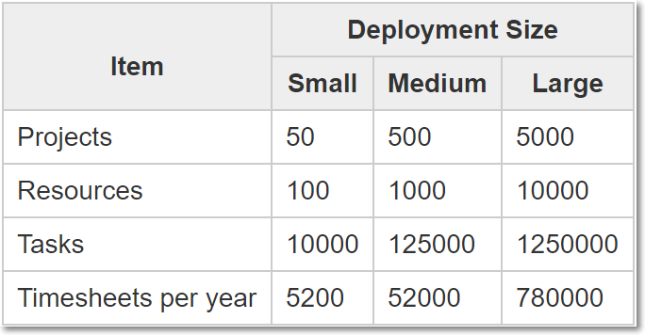

1

    - USER CLASS-1

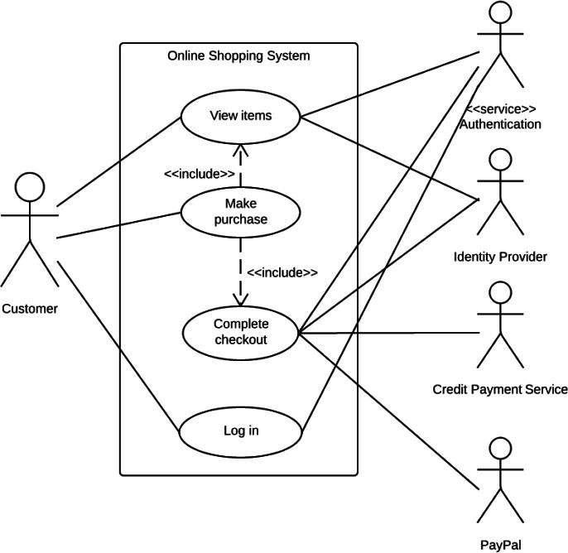

Figure 2.1: Use Case Diagram

2

SISTec/BTech/CS/2024/7/MajorProject_I/01

REFERENCES

JOURNALS / RESEARCH PAPERS
- Author surname, initials. (Year) Title of article, Journal name, Volume number (Issue or part number), first and last page numbers.
- Barnard, R.W. and Kellogg, C. (1980) ‘Applications of Convolution Operators to Problems in Univalent Function Theory’, Michigan Mach, J., Vol.27, pp.81–94.
- Shin, K.G. and Mckay, N.D. (1984) ‘Open Loop Minimum Time Control of Mechanical Manipulations and its Applications’, Proc.Amer.Contr.Conf., San Diego, CA, pp. 1231- 1236.

BOOKS
- Author surname, initials, ‘Book Title’, Publisher, Edition, Year of Publication.
- Pressman, R.S., and S.R. Herron, Software Shock, Dorset House, Edition 2, 1991.
- Troppen, Ulf and Erkens, Rainer, ‘Storage Networks Explained’, Wiley India, Edition 1, 1991.

WEBSITES (with exact URL up to page)
- http://library.northampton.ac.uk/liberation/ref/int_harvard_how.php
- http://www.nlm.nih.gov/bsd/uniform_requirements.html
- http://www.neilstoolbox.com/bibliography-creator/reference-journal.htm

PROJECT SUMMARY

About Project

Title of the project
Semester
Members
Team Leader
Describe role of every member in the project
What is the motivation for selecting this project?
Project Type
(Desktop Application, Web Application, Mobile App, Web)

Tools &Technologies

Programming language used
Compiler used
(with version)
IDE used
(with version)
Front End Technologies (with version, wherever Applicable)
Back End Technologies (with version, wherever applicable)
Database used
(with version)

Software Design& Coding

Is prototype of the software
developed?
SDLC model followed (Waterfall, Agile, Spiral etc.)
Why above SDLC model is
followed?
Justify that the SDLC model mentioned above is followed in
the project.
Software Design approach followed
(Functional or Object Oriented)
Name the diagrams developed
(According to the Design approach followed)
In case Object Oriented approach is followed, which of
the OOPS principles are covered in design?
No. of Tiers
(example 3-tier)
Total no. of front-end pages
Total no. of tables in database
Database in which Normal Form?
Are the entries in database
encrypted?
Front end validations applied
(Yes / No)
Session management done
(in case of web applications)
Is application browser compatible
(in case of web applications)
Exception handling done
(Yes / No)

Commenting done in code
(Yes / No)
Naming convention followed
(Yes / No)
What difficulties faced during
deployment of project?
Total no. of Use-cases
Give titles of Use-cases
Project Requirements

MVC architecture followed
(Yes / No)
If yes, write the name of MVC architecture followed
(MVC-1, MVC-2)
Design Pattern used
(Yes / No)
If yes, write the name of Design Pattern used
Interface type
(CLI / GUI)
No. of Actors
Name of Actors
Total no. of Functional Requirements
List few important non- Functional Requirements
Testing

Which testing is performed?
(Manual or Automation)
Is Beta testing done for this project?

Write project narrative covering above mentioned points

Raj Kumar 0187CS201127 Guide Signature

Ronak Mewada 0187CS201127
Jeevesh Sahu 0187CS201127
Rajnish Kumar 0187CS201127
(Guide name)

SISTec/BTech/CS/2025/7/MajorProject_II/01

APPENDIX-1 GLOSSARY OF TERMS
(In alphabetical order)

B
BER Bit Error Rate. The number of bits received in error. Usually, the number is quite low and expressed as a ratio in scientific notation. 10-2 means one-bit in 100 is received in error.
BPSK Binary Phase Shift Keying. A modulation method that encodes bits as phase shifts. One of two phase shifts can be selected to encode a single bit.
BSS Basic Service Set. The building block of 802.11 networks. A BSS is a set of stations that are logically associated with each other.
BSSID Basic Service Set Identifier. A 48-bit identifier used by all stations in a BSS in frame headers.

C
CCITT Comité Consultat if International Télé- graphique et Téléphonique. A UN body responsible for telephone standardization. Due to a reorganization, it is now called the International Telecommunication Union-Telecommunication Standardization Sector (ITU-T).
CCK Complementary Code Keying. A modulation scheme that transforms data blocks into complex codes and is capable of encoding several bits per block.
CF Contention Free. Services that do not involve contention for the medium are contention-free services. Such services are implemented by a Point Coordinator (PC) through the use of the Point Coordination Function (PCF). Contention-free services are not widely implemented.

